**BANK LOAN REPORT QUERY DOCUMENT**

1. **BANK LOAN REPORT | SUMMARY**

**KPI’s:**

**Total Loan Applications**

SELECTCOUNT(id)AS Total_Applications FROM bank_loan_data



**MTD Loan Applications**

SELECTCOUNT(id)AS Total_Applications FROM bank_loan_data

WHEREMONTH(issue_date)= 12



**PMTD Loan Applications**  
SELECTCOUNT(id)AS Total_Applications FROM bank_loan_data

WHEREMONTH(issue_date)= 11



**Total Funded Amount**

SELECTSUM(loan_amount)AS Total_Funded_Amount FROM bank_loan_data



**MTD Total Funded Amount**

SELECTSUM(loan_amount)AS Total_Funded_Amount FROM bank_loan_data

WHEREMONTH(issue_date)= 12



**PMTD Total Funded Amount**

SELECTSUM(loan_amount)AS Total_Funded_Amount FROM bank_loan_data

WHEREMONTH(issue_date)= 11



**Total Amount Received**

SELECTSUM(total_payment)AS Total_Amount_Collected FROM bank_loan_data



**MTD Total Amount Received**

SELECTSUM(total_payment)AS Total_Amount_Collected FROM bank_loan_data

WHEREMONTH(issue_date)= 12



**PMTD Total Amount Received**

SELECTSUM(total_payment)AS Total_Amount_Collected FROM bank_loan_data

WHEREMONTH(issue_date)= 11



**Average Interest Rate**

SELECTAVG(int_rate)*100 AS Avg_Int_Rate FROM bank_loan_data



**MTD Average Interest**

SELECTAVG(int_rate)*100 AS MTD_Avg_Int_Rate FROM bank_loan_data

WHEREMONTH(issue_date)= 12



**PMTD Average Interest**

SELECTAVG(int_rate)*100 AS PMTD_Avg_Int_Rate FROM bank_loan_data

WHEREMONTH(issue_date)= 11



**Avg DTI**

SELECTAVG(dti)*100 AS Avg_DTI FROM bank_loan_data



**MTD Avg DTI**

SELECTAVG(dti)*100 AS MTD_Avg_DTI FROM bank_loan_data

WHEREMONTH(issue_date)= 12



**PMTD Avg DTI**

SELECTAVG(dti)*100 AS PMTD_Avg_DTI FROM bank_loan_data

WHEREMONTH(issue_date)= 11



**GOOD LOAN ISSUED**

**Good Loan Percentage**

SELECT

(COUNT(CASEWHEN loan_status='Fully Paid' OR loan_status='Current'THEN id END)* 100.0)/

COUNT(id)AS Good_Loan_Percentage

FROM bank_loan_data



**Good Loan Applications**

SELECTCOUNT(id)AS Good_Loan_Applications FROM bank_loan_data

WHERE loan_status='Fully Paid' OR loan_status='Current'



**Good Loan Funded Amount**

SELECTSUM(loan_amount)AS Good_Loan_Funded_amount FROM bank_loan_data

WHEREloan_status='Fully Paid' OR loan_status='Current'



**Good Loan Amount Received**

SELECTSUM(total_payment)AS Good_Loan_amount_received FROM bank_loan_data

WHEREloan_status='Fully Paid' OR loan_status='Current'



**BAD LOAN ISSUED**

**Bad Loan Percentage**

SELECT

(COUNT(CASEWHEN loan_status='Charged Off'THEN id END)* 100.0)/

COUNT(id) AS Bad_Loan_Percentage

FROM bank_loan_data



**Bad Loan Applications**

SELECTCOUNT(id)AS Bad_Loan_Applications FROM bank_loan_data

WHEREloan_status='Charged Off'



**Bad Loan Funded Amount**

SELECTSUM(loan_amount)AS Bad_Loan_Funded_amount FROM bank_loan_data

WHERE loan_status='Charged Off'



**Bad Loan Amount Received**

SELECTSUM(total_payment)AS Bad_Loan_amount_received FROM bank_loan_data

WHERE loan_status='Charged Off'



**LOAN STATUS**

SELECT

loan_status,

COUNT(id)AS LoanCount,

SUM(total_payment)AS Total_Amount_Received,

SUM(loan_amount)AS Total_Funded_Amount,

AVG(int_rate* 100)AS Interest_Rate,

AVG(dti* 100)AS DTI

FROM bank_loan_data

GROUPBY loan_status

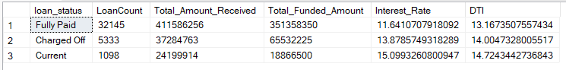

SELECT

loan_status,

SUM(total_payment)AS MTD_Total_Amount_Received,

SUM(loan_amount)AS MTD_Total_Funded_Amount

FROM bank_loan_data

WHERE MONTH(issue_date)= 12

GROUPBY loan_status

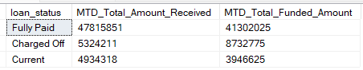

1. **BANK LOAN REPORT | OVERVIEW**

**MONTH**

SELECT

MONTH(issue_date) AS Month_Munber,

DATENAME(MONTH,issue_date)AS Month_name,

COUNT(id)AS Total_Loan_Applications,

SUM(loan_amount)AS Total_Funded_Amount,

SUM(total_payment)AS Total_Amount_Received

FROM bank_loan_data

GROUPBY MONTH(issue_date),DATENAME(MONTH,issue_date)

ORDERBY MONTH(issue_date)

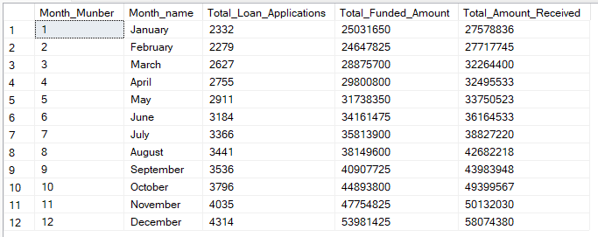

**STATE**

SELECT

address_state AS State,

COUNT(id)AS Total_Loan_Applications,

SUM(loan_amount)AS Total_Funded_Amount,

SUM(total_payment)AS Total_Amount_Received

FROM bank_loan_data

GROUPBY address_state

ORDERBY address_state

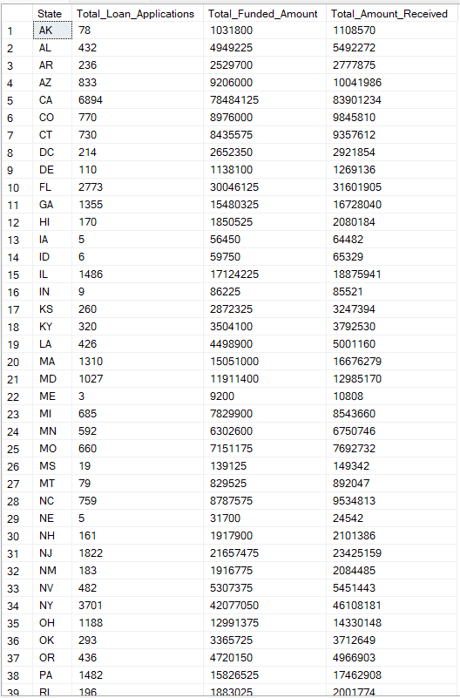

**TERM**

SELECT

term AS Term,

COUNT(id)AS Total_Loan_Applications,

SUM(loan_amount)AS Total_Funded_Amount,

SUM(total_payment)AS Total_Amount_Received

FROM bank_loan_data

GROUPBY term

ORDERBY term

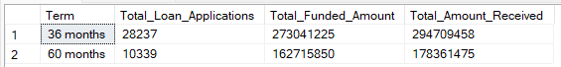

**EMPLOYEE LENGTH**

SELECT

emp_length AS Employee_Length,

COUNT(id)AS Total_Loan_Applications,

SUM(loan_amount)AS Total_Funded_Amount,

SUM(total_payment)AS Total_Amount_Received

FROM bank_loan_data

GROUPBY emp_length

ORDERBY emp_length

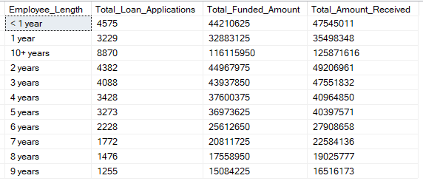

**PURPOSE**

SELECT

purpose AS PURPOSE,

COUNT(id)AS Total_Loan_Applications,

SUM(loan_amount)AS Total_Funded_Amount,

SUM(total_payment)AS Total_Amount_Received

FROM bank_loan_data

GROUPBY purpose

ORDERBY purpose

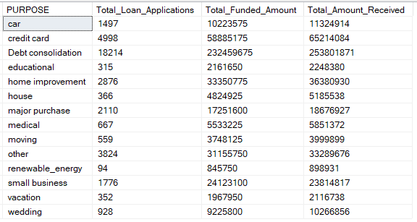

**HOME OWNERSHIP**

SELECT

home_ownership AS Home_Ownership,

COUNT(id)AS Total_Loan_Applications,

SUM(loan_amount)AS Total_Funded_Amount,

SUM(total_payment)AS Total_Amount_Received

FROM bank_loan_data

GROUPBY home_ownership

ORDERBY home_ownership

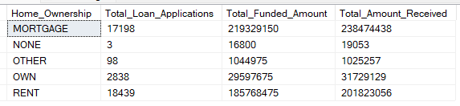

*See the results when we hit the Grade A in the filters for dashboards.*

*SELECT*

*purpose AS PURPOSE,*

*COUNT(id)AS Total_Loan_Applications,*

*SUM(loan_amount)AS Total_Funded_Amount,*

*SUM(total_payment)AS Total_Amount_Received*

*FROM bank_loan_data*

*WHERE grade ='A'*

*GROUPBY purpose*

*ORDERBY purpose*